I. Introduction

In the most recent financial crisis, the coordination of Quantitative Easing, monetary and fiscal policy has signaled a departure from classical economic theory in the government’s attempt to ensure macroeconomic fluctuations within trends of historical gross domestic product, GDP. Classical economic theory developed by Milton Friedman, Friedrich Hayek, and John Maynard Keynes provides insight on how governments should enact fiscal and monetary macroeconomic policy in reaction to fluctuations of the business cycle. The case for QE will be evaluated using the classical economics approach in the conclusion of this paper after evaluating the events that led toward their abandonment.

The United States Federal Reserve, the Fed, in conjunction with the Treasury, and policymakers have reacted to the financial meltdowns of 2007 and 2008 with questionable fiscal and monetary policy that has culminated in the Federal Reserve’s Implementation of Quantitative Easing. The fear of operating within a liquidity trap has led to the expansion of the Fed’s balance sheet and draining of the Treasury to inject liquidity into credit markets. The practice of QE is preceded, by historical example in Japan, with deleterious results. The potential implications of QE, as enacted by the US Fed, has the ability to counter the targets of price stability and stable employment as decreed and other targets of a Central Bank’s mandate. One of the most serious implications posed by QE is the effect on market expectations for the stability of the financial system. In conclusion, classical fiscal and monetary policy theory will be used to evaluate the effectiveness of fiscal and monetary policy, and the effects of government intervention on expected economic outcomes.

II. What is Q.E. & Why is it Used?

Richard Werner, a German economist, coined the term “quantitative easing,” QE, in the early 1990’s and elaborated on the target variables for such a policy in a case study of Japan’s economy following an asset price bubble in the early 1990s (Voutsinas & Werner). Werner’s case study of Japan provides a very relevant example with many parallels to economic conditions preceding the use of QE in the US and will be reviewed after first understanding why we use QE.

The Bank of Canada, BOC, defines QE as the “purchase by a central bank of financial assets through creation of central bank reserves. As a result, the price of the purchased assets, which can include government securities or private assets, rises and the yield on the assets falls.” The intended transmission mechanism of QE is the resultant expansion of a bank’s balance sheet in the form of reserves held by the commercial banks at the central bank, thus encouraging the commercial banks to increase the supply of credit to households and businesses. The BOC distinguishes its QE from what the US posits as “QE.” The BOC defines the U.S.’s phrasing of QE to be credit easing, CE. According to the BOC, “credit easing is the targeted purchase by a central bank of private sector assets in certain credit markets which are important to the functioning of the financial system. The goal of credit easing is to reduce risk premiums and improve liquidity and trading activity in specific markets so that credit will flow and increase demand in the economy.” QE is a unique policy in that the government steps beyond its role as a regulatory agency as an authority intent on intervention to achieve specific market outcomes. There is great risk of introducing market inefficiencies due to government intervention as predicted by classical economic theory, which will be discussed in the conclusion of this paper. Despite the resultant inefficiencies, no government would enact QE unless there were deep flaws in the market’s ability to naturally achieve equilibrium. In our most recent economic crisis the financial sector was a victim of its own innovation to create securities with increasing rates of return. The price of these assets generating increasing rates of returns was not adequately reflected in respect to their risks. The returns on the debt instruments sold in the credit markets resultantly shape investment portfolios, and the risks taken on those perceived safe debts strongly impacts the composition of a portfolio and choice of equity investments. The prevalence, complexity, and return on these secured and collateralized debt instruments generated systemic risk disproportionate to their market capitalization and eventually crippled financial institutions when their values collapsed. When the credit markets fail businesses face issues with liquidity. The illiquidity is a result of the credit markets adjusting risk premiums during the period of revaluation. The illiquidity in credit markets negatively impacts the cash flows of businesses and will resultantly decrease economic output and gross domestic product, GDP. At this point the severity of the collapse becomes political and relevant and a central bank must decide on the most appropriate response to reduce contagion (“*Monetary Policy in the Financial Crisis”)*. A central bank, CB, would typically respond by fulfilling its role as lender of last resort and enact expansionary monetary policy. The fear is that the damage due to the collapse in asset prices is beyond the regulatory power of the CB and to return to positive economic growth there must be an adjustment in market expectations. This fear is realized when the tools of the CB are ineffective in returning the vitality of markets despite increasing output and that economy is said to have entered a liquidity trap. The New York Federal Reserve Bank defines the liquidity trap “as a situation in which the short-term nominal interest rate is zero.” Classic Keynesian theory emphasizes that increasing the money supply when in liquidity trap generates no real economic effect. Under the conditions of a liquidity trap monetary policy is ineffective (Eggertsson). Despite the CB creating prime conditions for investment, loans are not being made because of market expectations. What is important is not the current money supply but managing expectations about the value of the future money supply in the face of expansionary monetary policy. To solve this problem the CB must now directly address the source of the illiquidity. With QE the CB does more than function as the lender of last resort, providing liquidity, but directly engages in the purchase of toxic assets in the market, serving the role as the “greater fool.”

III. Historical Example of Q.E.

The end and beginning of the 20th and 21st centuries are termed the lost decades for the Japanese economy. Decreased economic growth and high levels of unemployment characterized these two lost decades. The lost decades were preceded by an appreciation of the Japanese currency that negatively impacted Japan’s trade balance. The appreciation of the Yen, as result of the 1985 Plaza Accord, was accompanied with increasing purchasing power and increasing domestic asset prices. The post WWII historical economic characteristics of the Japanese economy reflected expectations that proved favorable to the levels of reinvestment that led to a dramatic increase in asset prices creating a bubble in the housing and stock market as a result of expansionary monetary policy. The Bank of Japan, BOJ, sought to decrease investment by increasing interest rates and imposing stricter lending conditions; thus triggering a collapse in asset prices (“*The Japanese Banking Crisis*…”). Japan’s economy subsequently faced a liquidity crisis and created the Fiscal Investment and Loan Program, FLIP, to provide liquidity to struggling businesses. The inclusion of the FLIP and other debt programs issued by the Japanese government catapulted Japan to be leveraged out by roughly 2x GDP within three years of inception of these programs. The failure of monetary and fiscal policy then led to a commitment of QE. Japan adopted a risk averse attitude towards investment following World War II. The investment attitude of Japan regarded savings as virtuous. Japanese attitudes toward investment are best reflected by portfolio analysis using the Capital Asset Pricing Model to distinguish preference of risk and return between Japanese and U.S. investors (Nakagawa and Shimizu). The degree of relative risk aversion shows the willingness of a household to purchase risky assets according to the difference between the expected rate of return on risky assets and the rate of return on safe assets under the risk of change in risky asset prices in one year. For example, assuming that the risk of change in risky asset m prices is constant, the degree of relative risk aversion is large when the actual ratio of risky assets does not change very much following a change in the expected rate of return on risky assets and the rate of return on safe assets. Data for Japanese households implies that these households are relatively risk averse (“*Risk-Averting Portfolio of Japanese Households* “). This assumption proves true when looking to the composition of total and net assets held by Japanese households during the boom in the Nikkei stock index in 1989, and the subsequent dot-com boom of the late 1990’s. Looking to the sheer composition of total and net assets of Japanese households over the long-term, roughly two-thirds of total and net assets are held as physical assets and land. The composition of assets reflects that the majority of Japanese household investment is in home ownership peaked in value in 1990 at 2.7 trillion Yen. Financial assets exceed land in 1995 but the value of these net financial assets consistently remains less than the value of land and physical assets over that time period (Okina et al.). Despite the Nikkei 225 price-weighted stock index cresting at 38,915.87 on December 29, 1989 physical assets and land remained the majority of investment held by Japanese households. In response the increase in asset prices the BOJ reacted pre-emptively with monetary policy as predicted by the Taylor Rule. The Taylor Rule relates the operational function of a central bank to regulate variables that affect the target of stable inflation and minimizing the output gap. The BOJ recognized overvaluation in the real estate and stock market and raised the discount rate from 2.5% in 1987 to 6% by 1990 to decrease speculative activity. By 1992 the Nikkei lost over 60% of its peak value, and housing prices plummeted by roughly 80%. The collapse in these asset prices represented a failure of monetary policy to curb fluctuations in GDP and led the Japanese government to implement fiscal policy to stimulate the economy following expansionary monetary policy (“*Why Did the Nikkei Crash?...*”). Japan created the Fiscal Investment and Loan Program, which drew money from postal saving accounts and provided loans to industries of priority. This program allowed the Japanese government to increase spending without increasing taxation. FILP was funded by the selling of bonds to the public in an effort to reduce long-term interest rates. In this effect, the private sector was being bought out using public funding. This program came under scrutiny due to the tendency for funds to be loaned to those corporations supported by the Liberal Democratic Party, LDP (*The asset price bubble in Japan in the 1980s…).* In conclusion the FILP failed to stimulate investment in Japan and hampered efficient allocation of resources within the market. The Bank of Japan was the first to enact QE in March 2001. The proposed transmission mechanism for the BOJ’s QE policy consisted of an asset supply channel and a monetary base channel. The goal of the BOJ’s central banking mandate is described as including the stimulation of the economy as measured by nominal GDP, with the implied intermediary goal of providing sufficient liquidity in bank lending. The BOJ’s QE policy consisted of three key elements. First, the BOJ tailors its mandate by prioritizing main operating target to the outstanding current account balances (CABs) held in the form of reserve deposits at the BOJ and ultimately boosted the CAB well in excess of required reserves. The BOJ announced in 2001 that it would increase the CAB surplus by 1 trillion Yen to 5 trillion yen in an effort to lower the uncollateralized overnight call rate to a target level within 0.15% of zero percent. Second, the BOJ boosted its purchases of government bonds and other assets, in order to help achieve the targeted increases in CABs, by 400 billion yen per month. Third, the BOJ announced its dedication to a policy of QE until the CPI indicated a reverse in the trend for deflation.

The first real indicative result of QE to the BOJ was experienced 6 months after the announcement in September 2001. After the first six months of the BOJ enacting QE policy, Japan experienced an appreciation of its currency from 0.0084 Yen/USD in September 2001, to an exchange rate of 0.0075 Yen/USD. This appreciation can be attributed to the damages of the September 2001, terrorist attack in the U.S. and a relative flight to safety. This flight to safety was short lived and marked the lowest exchange rate that Japan would experience in modern history. By July 2002, the Yen had depreciated to an exchange rate of 0.0085 Yen/USD and has continued to depreciate in the face of consecutive rounds of QE. The Yen exchanged for USD in October 2011 was 0.0130 Yen/USD, a 55% decrease in value. The BOJ ultimately failed to achieve its policy goals. Despite the Japanese example, history of this failure was not sufficient to keep the U.K. and U.S. from implementing their own programs of QE. Diagrams of the transmission mechanism of QE and U.K. are supplied to represent the complexity of such programs. Ultimately, the government despite pursuing various direct avenues towards increasing investment fails to achieve this market outcome because of its sheer desperation. The commitment to QE signals negatively to the expectations of government credibility on behalf of consumers and investors in the face of the government willing to erase the effects of economic turmoil that it could not adequately predict nor regulate.

IV. Current use of Q.E. The current use of QE in the US is a response to the financial crisis of 2007-2008 that was punctuated by a bubble in the housing market. The rising number of delinquencies of subprime mortgages created substantial losses on financial institutions’ balance sheets due to the collapse of these derived asset-backed securities. The current use of Q.E. in the US dates back to the attempts by the Fed to use the conventional policy tool of adjusting the federal funds rate to influence lending conditions in late 2007. To avoid liquidity crisis the Fed lowered the federal funds rate to increase interbank loaning and reserves and increased the discount window loan period to 90 days. By December 2008, the Fed had established a target range for the federal funds rate to be between 0 and 25 basis points (“*The Crisis and the Policy Response* “). These changes greatly increased reserves held at the Fed, thereby expanding liabilities to the Fed’s balance sheet. To counter the increase in liabilities, the fed began a series of programs to purchase risky assets to further promote liquidity. This alteration in the policy approach led the Fed to expand directly into credit markets to provide liquidity. At this point the implementation of QE achieves its notoriety for being an unconventional approach by effectively functioning as a financial intermediary and safeguard.

The best capitulation for reasons why the Fed decided to enact QEII was

provided by the Director of the Board of Governors at a Conference at the Federal

Reserve Bank of Kansas City Economic Symposium: “Under what conditions would the FOMC make further use of these or related policy tools? At this juncture, the Committee has not agreed on specific criteria or triggers for further action, but I can make two general observations. First, the FOMC will strongly resist deviations from price stability in the downward direction. ... It is worthwhile to note that, if deflation risks were to increase, the benefit-cost tradeoffs of some of our policy tools could become significantly more favorable.

Second, regardless of the risks of deflation, the FOMC will do all that it can to ensure continuation of the economic recovery. Consistent with our mandate, the Federal Reserve is committed to promoting growth in employment and reducing resource slack more generally. Because a further significant weakening in the economic outlook would likely be associated with further disinflation, in the current environment there is little or no potential conflict between the goals of supporting growth and employment and of maintaining price stability.”

Since the start of the financial crisis in 2007, the Fed has created numerous programs to facilitate the objectives of QE; these agencies include the Term Auction Facility (TAF), Central Bank Liquidity Swap Lines and Foreign Currency Liquidity Swap Lines, the Primary Dealer Credit Facility (PDCF), Term Securities Lending Facility (TSLF), TSLF Options Program (TOP), Asset-Backed Commercial paper Money Market Mutual Fund Liquidity Facility (AMLF), Commercial Paper Program (CPP), Money Market Investor Funding Facility (MMIFF), Term Asset-Backed Securities Loan Facility (TALF), Agency Mortgage-Backed Securities (MBS) purchase program, and the Government-Sponsored Enterprise (GSE) Direct Obligation Program. These programs fall under the Large-Scale Asset Purchase Program that was announced in late 2008 with the purchase of housing agency debt and mortgage-backed securities of $600 billion. In March 2009, the Fed announced purchase of long-term government securities worth $1.75 trillion to effectively decrease the yield on these long-term debt instruments.

The disadvantage of lowering the yield on interest rates is that banks must decrease the interest rate on dollar-denominated securities. Ordinarily, investors would channel funds towards those accounts which yield the high return. The US was cushioned from a net outflow of capital due to crises in the Eurozone. Nevertheless, the USD has experienced a depreciation of roughly 6% which would be undoubtedly much more significant if economic conditions were more stable in Europe.

V. Potential Implications of QEIII: The dollar overtook the British pound sterling in the 1920s and has since then enjoyed tremendous advantages as the world’s reserve currency. The USD functioning as the reserve currency is insulated from foreign, shocks, reduces transaction costs in trade and finance, and contributes to the international transmission mechanisms of US shocks and monetary policy (“*The Rise and Fall of the Dollar…”).* Foreign countries use the USD because of the stability of the US economy, and historically low and steady inflation as insurance in the event of a flight to safety. Foreign countries hold USD reserves to stabilize future transactions and shifts in the valuation of that foreign country’s exchange rate. The need for increasing USD reserves was made evident during the East Asian speculative crisis during the late 1980s following the implementation of a floating exchange rate in these Asian countries. These Asian countries abandoned their pursuit of a floating exchange rate in favor of a fixed exchange rate to the USD. QE has served to depreciate the value of the dollar, thus helping businesses within the US to export to other countries. This increase in exports, however, does not contribute to the overall health of the economy when considering the increasing leverage on the debt to GDP ratio. The US is currently in debt of $16 trillion dollars. The major claimants to the US debt include other countries’ central banks like China, Japan and the U.K. The top holder of US debt, however, is the US itself. As the major holder of US debt, when the Fed decides to increase its holdings there are considerable effects in the economy. There is, however, a lag between the time in which the Fed announces its plan to increase holdings of treasury securities and the actual accrual of those securities. Returning to one of QE’s instruments, communication, it is possible to track trends in the economy as the result of the Fed’s asset purchase programs. Each time the Fed chooses to expand its balance sheet, it induces fluctuations in the prices of commodities. The commodities of concern include following the announcement of QEI & II share information of expectations adjusting to future inflation with a decline in value of the UUP, an ETF that tracks the position of long positions in certain futures contracts between the Deutche Mark and USD, and TLT, an index fund that measures the performance of public obligations of the US that have a remaining maturity of 20 or more years. The decline in value of the UUP and TLT corresponds to attitudes about these investments. The correlation between the expected increase in risk and its effect on interest rates is best reflected by the downgrade on US debt from AAA to AA. Despite the Fed lowering the federal funds rate, and covering the value of toxic assets, the credibility of the Fed has been compromised such that future announcements of QE are likely to increase investors’ expectations of the US to become a riskier debt issuer and this correlates with investors demanding higher amounts of interest on US debt and purchase of a better store of value as reflected by the increasing price of gold.

The Fed was able to promote price stability during the initial six-month period after announcing rounds of QEI & QEII but these values become very unstable thereafter. The Fed has been unable so far in the first two rounds of QE to inject price stability outside of the short-lived stimulus from injecting money into the economy. So what has been the real effect of QE on investment in the economy? The real effect of QE operating within the liquidity trap in the US economy is depreciation of the USD, an increase in debt and nearing the “fiscal cliff.” The Fed’s balance sheet operates with increased liabilities in the form reserves and subsequently the increased cash in circulation depreciates the value of the USD (“*The Federal Reserve’s Balance Sheet”)*. The Fed has also has transformed its ownership of government securities by the inclusion of private debt. In effect the Fed has balanced a near-zero interest rate asset on its balance sheet by purchasing short-term government debt with a near zero interest rate asset in the form of cash or reserves at the Federal Reserve Bank. Despite the increase in liquidity and access to money, banks have become indifferent between the low interest bearing government debt securities and cash reserves. QE has failed to shift the balance sheets of member bank into making loans or providing liquidity for businesses and investors thus having no impact on the member banks’ lending activity. The amount of money being pumped into the economy ultimately results in a devaluation of the currency and undermines the USD’s status as a reserve currency.

VI. Conclusion:

Conclusions will be made on the basis of classical economic theory:

For the sake of brevity much more detail was elaborated in the historical precedent of QE in Japan rather than the US. The parallels between the fiscal policies, FILP and the American Recovery and Reinvestment Act of 2009, and effective monetary policies, QE and Credit Easing, bear such striking comparison that the benefit of data and analysis was given to the case of Japan and would appear redundant in the case of the US.

Theory developed by Milton Friedman and monetarists recognize the perils of

deflation following a recession and recommend inflationary monetary policy. The primary model of the monetarists is the Investment-Savings and Liquidity Preference Money Supply (IS/LM) tool, which relates interest rates and economic output of the macroeconomy. The central bank of a country can manipulate the interest rate to encourage spending and investment in an economy. Monetary policy is typically implemented by a Central Bank, CB, and the tools and targets of the CB are greater than manipulating nominal interest rates. The relationship between interest rates, investment and gross domestic product is elaborated best by the Austrian economic theory. The theory of Friedrich Hayek represents the Austrian school of economic thought and provides a cautionary tale of how to treat artificial booms. In contrast to the fiscal stimulus argued by Keynes, Friedrich Hayek warns that “those who advocated large-scale public spending programs to cure unemployment [are] inviting not just uncontrollable inflation but political tyranny (Koehn BU8).” Hayek relates the amount of money in circulation and the going interest rate in the marketplace as a positive relationship. When the government increases the amount of money in circulation chasing assets that are not in high demand, the interest rate on those investments will resultantly increase. Pressure on the return of assets will stimulate unnecessary risk. Keynes attributed the fluctuations in the business cycle to animal spirits. These animal spirits are what separate a rational human being and a normal person. These animal spirits can be characterized with the human emotions of exuberance and optimism that can sway rationality and will greatly impact expectations within a market and can lead to windfall profit and loss. In this paper the main concern is deflation associated with a recession. Deflation, or falling prices, makes individuals delay consumption, thus altering expectations about items to become cheaper in the future. Deflation also decreases borrowing, because falling prices corresponds to an appreciation of currency making repayment of debts more expensive.

Keynes concluded that markets do not adjust to full employment following a recession and that following these economic downturns there could be long periods of high unemployment. Keynes argued that it was the government’s responsibility to provide a fiscal stimulus to increase aggregate demand for goods and services to return the economy to previous levels of unemployment. One criticism of the Keynesian fiscal stimulus is that the government derived-demand produces inefficiency in the goods market. Oftentimes, the money from government stimulus goes towards goods that are inferior performers in the consumer market or towards goods more suitable to government demand than consumer demand. Proponents that highlight this inefficiency argue that the government puts pressure on the market to inefficiently allocate resources away from the natural market equilibrium. This effectively throws the economy into further disequilibrium following a recession and prolongs the market’s return to efficient resource allocation and acceptable levels of unemployment. The Fed has used QE to impact some forward guidance for how an economy should function. Despite their intentions, how the Fed would like the economy to function is not equivalent to the natural equilibrium of that economy. The Fed has taken great lengths to artificially strengthen demand and it reflects on the adage that you can bring a horse to water but not make it drink. Further injection of money into the credit markets will only generate another bubble. The major issue for the economy is debt, to which the Fed is a great contributor. The best outcome following an economic crisis of this magnitude is to have a government maintain its credibility by permitting markets to function as efficiently as possible.

Bibliography:

Ando, Koichi. Japan. Economic and Industrial Research Department, Development Bank of Japan . *Risk-Averting Portfolio of Japanese Households*. 2001. Print.

Badkar, Mamta. "CHART OF THE DAY: Global Central Banks Versus The World's Stock Markets Read more: http://www.businessinsider.com/chart-market-reactions-to-qe-and-long-term-repurchase-2012-9

Ben S. Bernanke. *The Federal Reserve’s Balance Sheet.* Federal Reserve Bank of Richmond 2009 Credit Markets Symposium, 2009. Charlotte, N.C.,: Board of Governors of the Federal Reserve System, 2009. Web. 5 April. 2012. <<http://www.federalreserve.gov/newsevents/speech/bernanke20090403a.htm>>.

Ben S. Bernanke. *The Crisis and the Policy Response*. London: London School of Economics, 2009. Web. 5 Dec. 2012. <http://www.federalreserve.gov/newsevents/speech/bernanke20090113a.htm>.

Barry Eichengreen, Flandreau. *The Rise and Fall of the Dollar, or When Did the Dollar Replace Sterling as the Leading Reserve Currency?* European Review of Economic History, Cambridge University Press, vol. 13(03), pages 377-411, December.

Eggertsson, Gauti B. . "Liquidity Trap." *The New Palgrave Dictionary of Economics*. 2008.

Hoshi, Kashyap. 2000. "[The Japanese Banking Crisis: Where Did It Come From and How Will It End?](http://ideas.repec.org/h/nbr/nberch/11047.html)." [NBER Chapters](http://ideas.repec.org/s/nbr/nberch.html), in: NBER Macroeconomics Annual 1999, Volume 14, pages 129-212 National Bureau of Economic Research, Inc.

Nakagawa and Shimizu. “Portfolio Selection of Financial Assets by Japan's Households: Why Japan’s Households Reluctant to Invest in Risky Assets.” Tokyo. Bank of Japan Monthly Bulletin, November 1999 issue.

Koehn, Nancy F. "The Tale of the Dueling Economists." *New York Times* [New York] 23 Oct 2011, BU8. Web. 5 Dec. 2012.

Chart 2: Lam, W.R., Tokuoka, R. (2011). Assessing the risks to the Japanese Government Bond (JGB) market. (IMF working paper ; 11/292). Retrieved from International Monetary Fund website: <<http://www.imf.org/external/pubs/ft/wp/2011/wp11292.pdf>>

**Diagram 1** Okina, Kunio, Masaaki Shirakawa and Shigenori Shiratsuka (2001): “The asset price bubble and monetary policy: experience of Japan’s economy in the late 1980s and its lessons”, Monetary and Economic Studies, 19 (S-1), Institute for Monetary and Economic Studies, Bank of Japan, pp 395-450.

Donald L. Kohn. *Monetary Policy in the Financial Crisis*. Nashville, TN: Board of Governors of the Federal Reserve System, 2009. Web. 5 Dec. 2012. <http://www.federalreserve.gov/newsevents/speech/kohn20090418a.htm>.

Shiller, Kon-Ya and Tsutsui. “Why Did the Nikkei Crash? Expanding the Scope of Expectations Data Collection.” *The Review of Economics and Statistics* , Vol. 78, No. 1 (Feb., 1996), pp. 156-164

Shiratsuka, Shigenori. 2005. “[The asset price bubble in Japan in the 1980s: lessons for financial and macroeconomic stability](http://econpapers.repec.org/RePEc:bis:bisbpc:21-05).” p. 42-62 in Settlements, Bank for International eds. Real estate indicators and financial stability, vol. 21, Bank for International Settlements.

Voutsinas and Werner. “New evidence on the effectiveness of ‘quantitative easing’ and the accountability of the central bank in Japan.” Working paper presented at the 15th Annual Meeting of the Annual International Conference on Macroeconomic Analysis and International Finance (ICMAIF 2011), University of Crete, Rethymnon, 27 May 2011; 8th Infiniti 2010 Conference on International Finance, Trinity College, Dublin, 14–15 June 2010; the 27th Symposium in Money Banking and Finance, Université Montesquieu-Bordeaux IV, 17–18 June 2010, and the MMF 2010 Annual Conference at the Cyprus University of Technology, Limassol (2010)

White, Rocky. "QE1 And QE2 Provide Investing Playbook For QE3." *Forbes*. Forbes, 24 2012. Web.

Supplemental Charts and Diagrams:

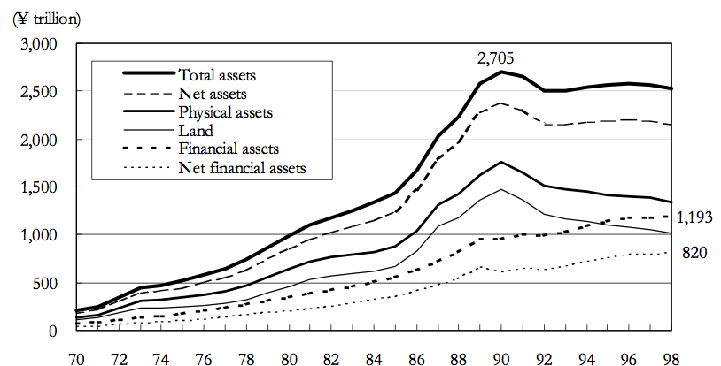

Chart Long Term Trends in Japanese Household Total and Net Assets (Ando, 2001)

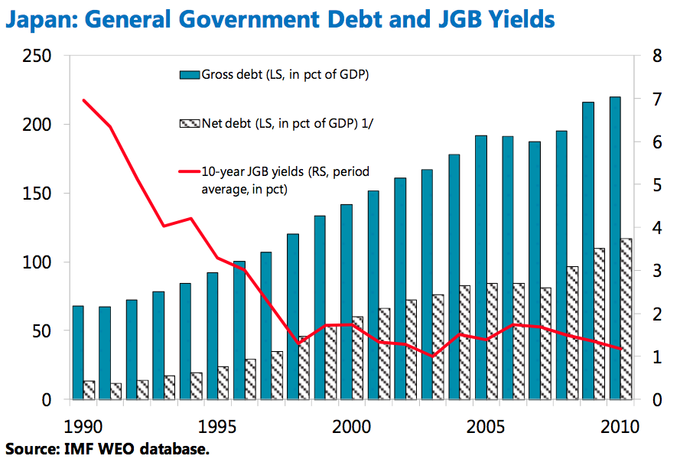

Chart General Government Debt and JGB Yields (Lam & Tokuoka, 2011)

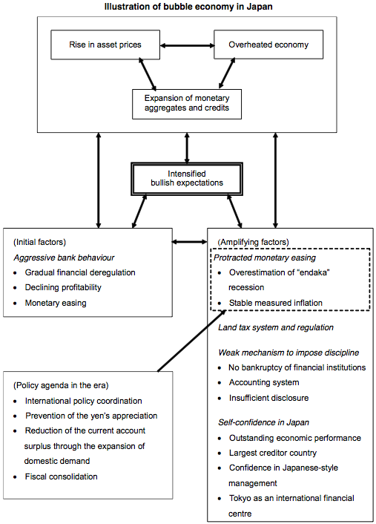

Diagram Illustration of bubble economy in Japan (Okina et al, 2001)

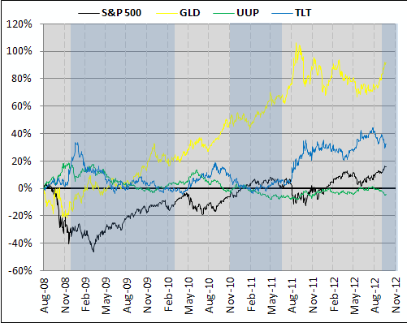

Chart Timeline QE and Equity, Bonds, and Gold Prices (White)